Step-by-Step Explanation of Simple 1D Nonlinear Image Registration Using Control Points (FNIRT Conceptual Example)

This section illustrates a simplified 1D conceptual example of nonlinear image registration using control points, similar to the approach used in FNIRT. In this 1D grid, spatial positions represent voxel coordinates, and the deformation of the moving image is controlled by a small set of control points. These control points generate a smooth displacement field through interpolation, allowing the moving image to gradually deform so that it aligns with the reference image while maintaining spatial smoothness.
In a real neuroimaging context:
- Reference (Fixed Target):
MNI152_T1_2mm_brain.nii.gz
(Standard template in MNI space)
- Moving Image:
(Subject’s structural MRI)
The goal is to compute a transformation that deforms the moving image so it matches the reference image while remaining smooth and anatomically realistic.

1) Spatial Positions (The Coordinate Grid)
In your simplified 1D example, the spatial grid is:
Positions:
0 1 2 3 4
These positions represent voxel coordinates of the reference image grid.
So:
Reference image intensities:
Position x | 0 | 1 | 2 | 3 | 4
f(x) | 15 | 25 | 35 | 35 | 15

Moving image intensities:
Position x | 0 | 1 | 2 | 3 | 4
g(x) | 10 | 20 | 30 | 40 | 50

Important principle:
Registration is performed on the reference grid.
Every computation is indexed by the reference positions x.
In real MRI, these positions are 3D voxel coordinates (x, y, z) in MNI space.

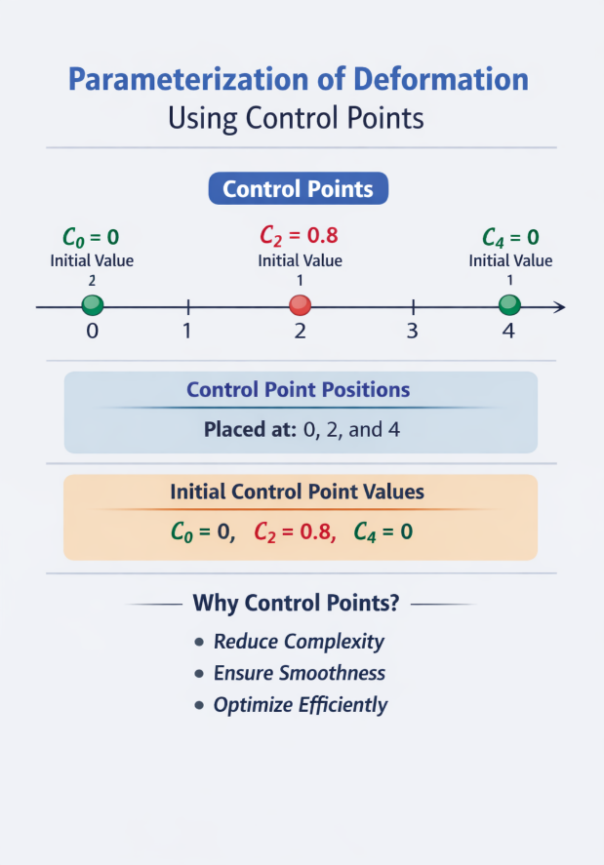
2) Parameterizing Deformation with Control Points
Instead of allowing each voxel to move independently, we define deformation using control points at:

0 | 2 | 4

Initial control values:
C0 = 0
C2 = 0.8
C4 = 0
These are the parameters optimized by the algorithm.
Why this is important:
- Reduces number of parameters
- Ensures smooth deformation
- Stabilizes optimization

3) Constructing the Warp Field
Using spline interpolation, the control points generate a smooth displacement field:
d(x) = [0, 0.4, 0.8, 0.4, 0]

This means:
- Position 2 moves most (0.8)
- Neighboring positions move less (0.4)
- Edges do not move
This guarantees spatial smoothness.
In real 3D registration, this would be a smooth 3D displacement field.

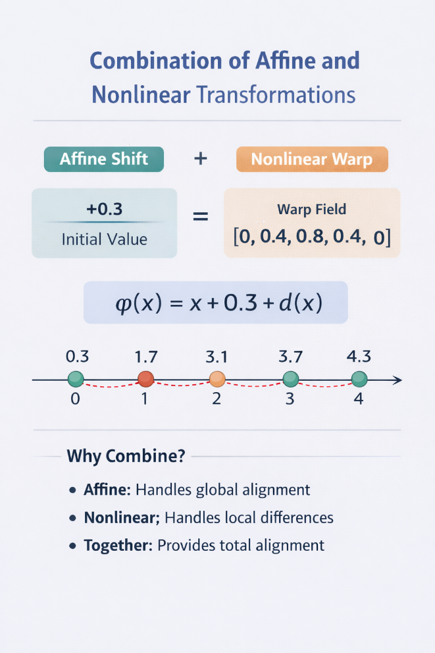
4) Full Transformation (Affine + Nonlinear)
Assume an affine shift:
A = +0.3
The total transformation becomes:
φ(x) = x + 0.3 + d(x)
So: φ(x) = [0.3, 1.7, 3.1, 3.7, 4.3]
Interpretation:
Each reference position x maps to a fractional coordinate in the moving image.
For example:
Reference position 2 samples moving position 3.1.
In real neuroimaging:
φ(x, y, z) maps MNI coordinates to subject coordinates.
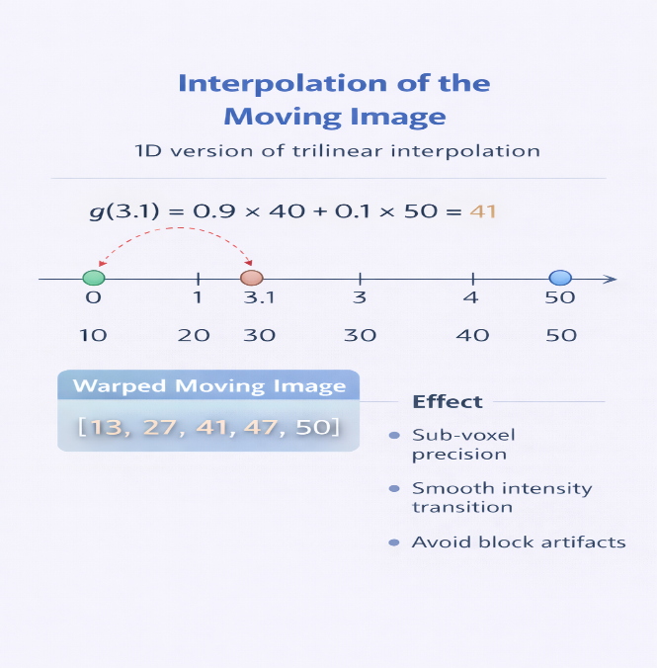
5) Interpolation
Because φ(x) produces fractional coordinates, interpolation is required.
After interpolation, the warped moving image becomes:
g(φ(x)) = [13, 27, 41, 47, 50]
Why interpolation is necessary:
- Allows sub-voxel accuracy
- Produces smooth intensity transitions
- Prevents aliasing artifacts

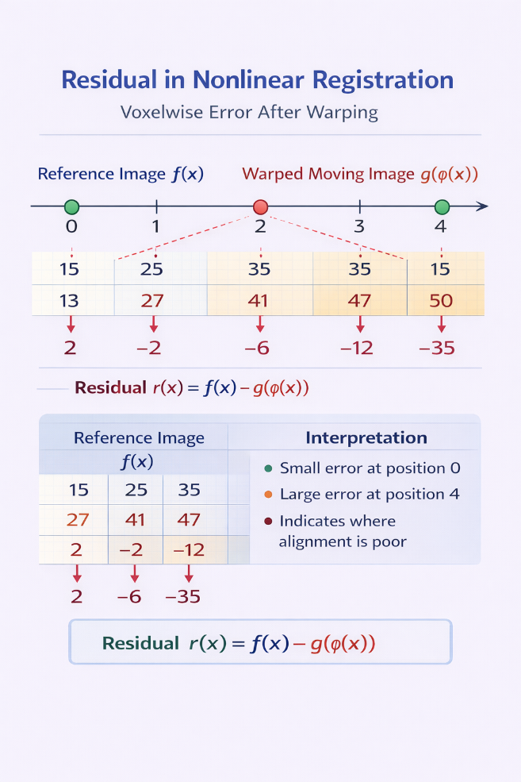
6) Residual (Voxel wise Error)
Residual is computed as:
r(x) = f(x) − g(φ(x))
Result:
[2, −2, −6, −12, −35]
This tells us:
- Small mismatch at early positions
- Large mismatch at position 4
Residual identifies where alignment is poor.

7) Sum of Square Differences:
SSD = 1413
This is the data fidelity term.
It quantifies how well the warped moving image matches the reference image.

8) Regularization (Smoothness Constraint)
Suppose smoothness penalty:
R(d) = 5
Regularization weight:
λ = 2
So:
λR(d) = 10
Why regularization is essential:
Without it, the algorithm may:
- Overfit noise
- Produce sharp unrealistic deformations
- Create biologically implausible warps
Regularization enforces smooth anatomical behavior.

9) Total Energy Function
E = SSD + λR(d)
E = 1413 + 10 = 1423
This is the objective function minimized during optimization.
The algorithm adjusts control points to minimize E.

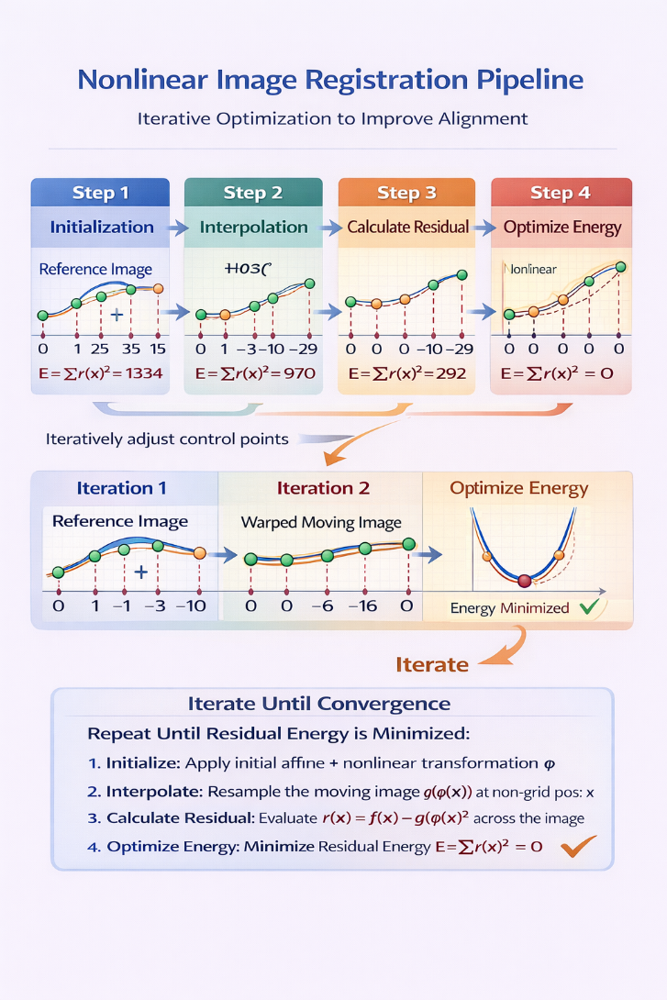
10) Gradient and Update
The algorithm computes:
“How does E change if C2 changes?”
Changing C2 affects:
- Warp field
- Mapping φ(x)
- Interpolation
- Residual
- SSD
- Total energy
Suppose:
ΔC2 = −0.3
New C2 = 0.5
This reduces deformation strength.

11) Recompute and Improve
New warp:
[0, 0.25, 0.5, 0.25, 0]
Suppose:
New SSD = 900
New penalty = 4
New total energy:
E = 900 + 8 = 908
Energy decreased from 1423 to 908.
This confirms improvement.

12) Iterative Optimization
The process repeats:
- Build warp
- Transform positions
- Interpolate
- Compute residual
- Compute SSD
- Add regularization
- Compute gradient
- Update control points
Until convergence.

13) Final Output
Warp coefficients:
sub-01_T1_to_MNI_warpcoef.nii.gz
This transformation can then be applied to:
- Functional MRI
- Segmentations
- Diffusion data
- Any subject image

This simplified 1D example is used only to make the nonlinear registration procedure easier to understand. In real neuroimaging applications, the same concept is applied in 3D space to voxel coordinates (x, y, z). The full 3D FNIRT registration process will be discussed in the next document.

